## **Table of Contents**

* About
* Getting Started
* Usage
* Built Using.

## User Interface

## Functionality

* Program flow

## **About**

Electronic Point of Sale (EPOS), as the name suggests, is a software system that performs all business tasks such as checkouts, payments, handling accounts, inventory management, etc.. The system is developed on the .NET framework using C# for its backend and Winforms for GUI. This project is set up for a different type of home clothing shop right now for user testing. EPOS has a built in payroll system, inventory management system, order system.

### **Prerequisites**

A Visual studio IDE has to be set up to allow EPOS to Run. Just open “Assignment 4.sln” file in the visual studio IDE and you will be ready to go. The forms that need to be updated with the DB source connection string are, InventoryMeny.cs, NewUser.cs, OrderScreen.cs,and Payroll.cs. The email system will also need to be updated with a valid email address and password.

1.Install .NET 4.5 Framework

2.Install Visual Studio IDE

2.Open Assignment4.sln

3.Press f5 to run the application in debug mode.

4.Run exe in ”...\Epos-system\EPOS system project\Assignment5\bin\Debug\Assignment4.exe”

5.Run the release build exe in ”...\Epos-system\EPOS system project\Assignment5\bin\Release\Assignment4.exe”

## **Usage**

The system can run on any windows system.

## **Built Using**

* Visual Studio - IDE
* .NET Framework - Framework
* C# - C# backend language

## **User Interface**

**Landing page**

The landing page of the system will consist of different choices. it consists of a list available for a customer to purchase(if they are in the stock), list of sizes for that item, you can also choose the quantity of item you want to purchase. A list of items you have added to the cart to proceed. With the order or transaction.

The 2nd part of the landing page consists of 3 buttons and and textbox showing the total value of order.

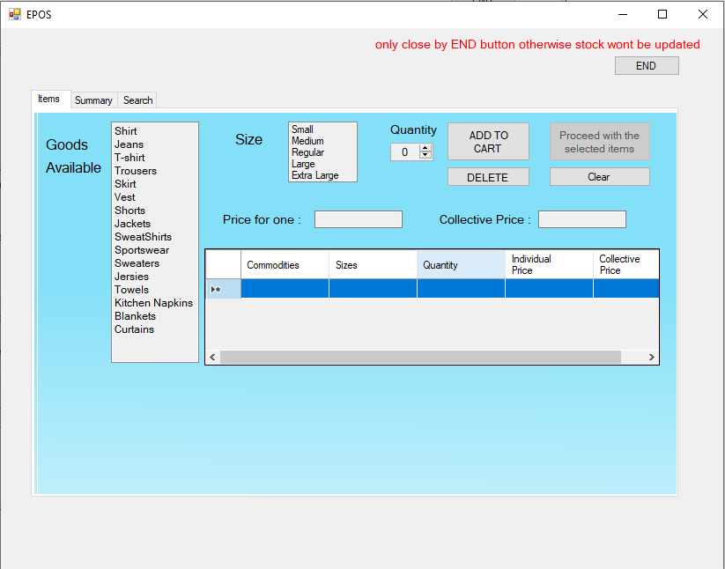

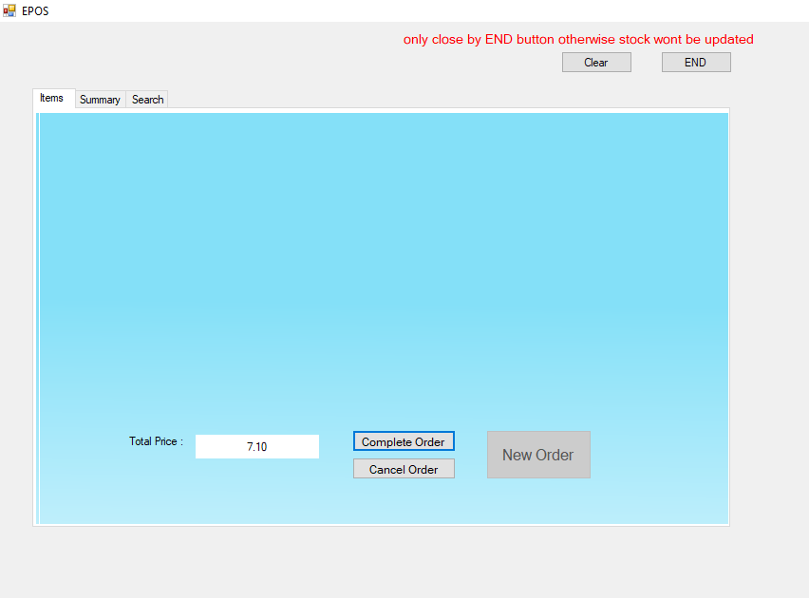

**Summary Page**

Summary page shows the daily sales of items such as Number of commodities sold, total sales, total number of transactions etc.

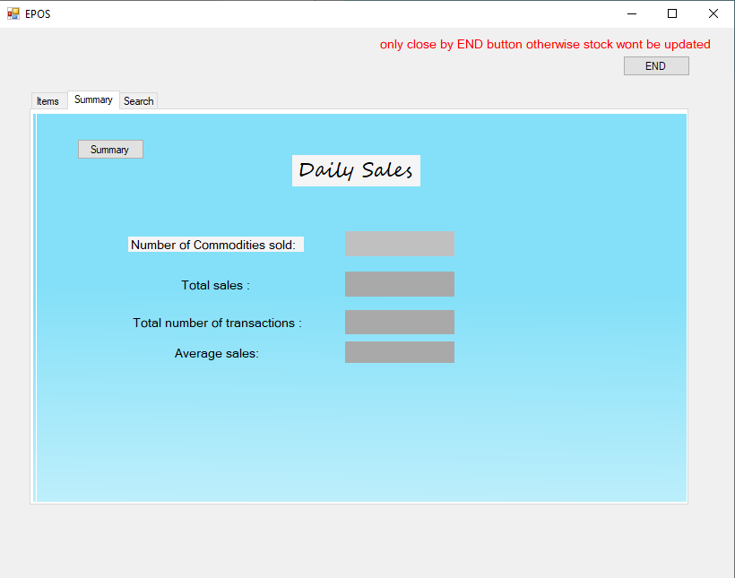

**Search Page**

Search page consists of a form in which you can add your orderId and can search for the previous transactions or order details etc.

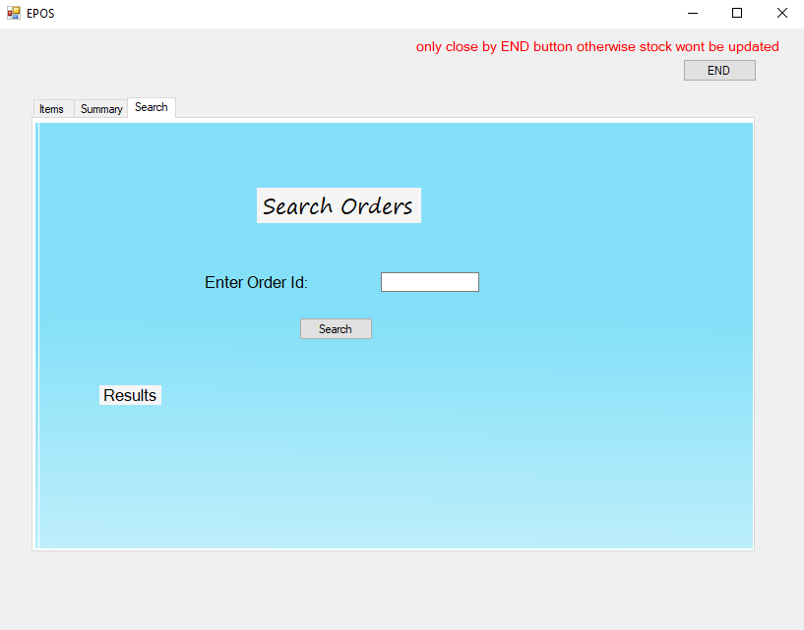

The end user UI will look like the above screenshot which is a combination of different options, different buttons etc.

## **Functionality**

This section will show the functionality or working of the system by explaining every aspect of the system.

When you will start an application on the landing page there are two lists of goods available and a size list.Choose the item you want to add , choose the size and then quantity.Proceed button will be disable at this time. You can also sell the price for one and the collective price of the items chosen will change according to the items you have chosen for the order.

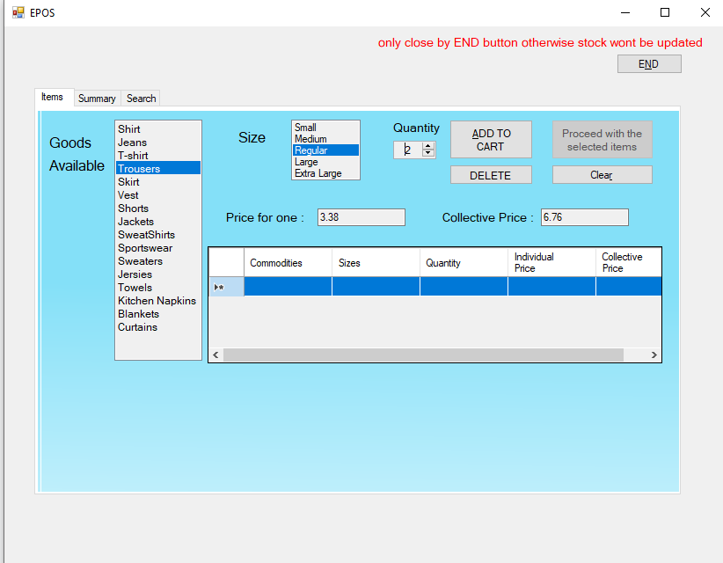

Press the Add button to add the chosen items in the cart. Now the proceed button gets enabled, quantity and collective price will become zero so that you can proceed to complete the order or you can also choose to add other items.

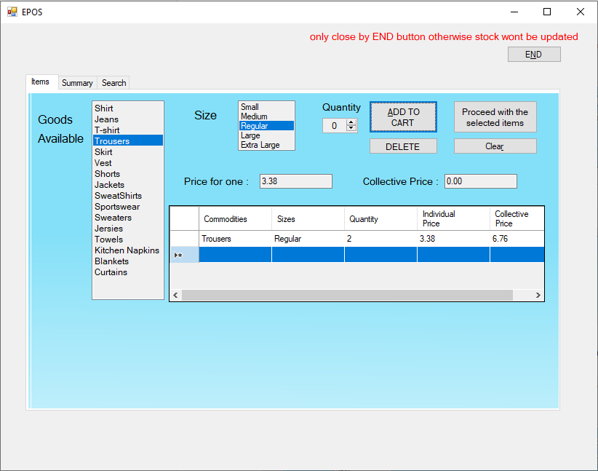

The Delete button will delete the selected row of the item added to the cart.

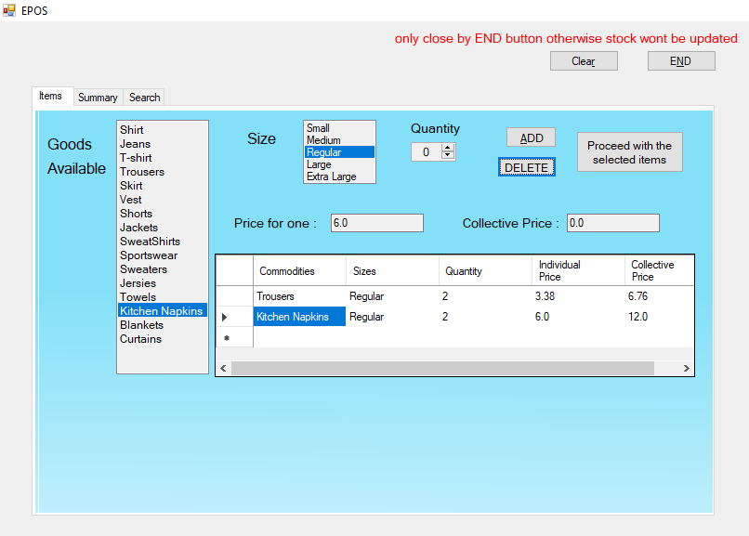

After clicking the delete button the selected item i.e. sportswear will be removed from the list.

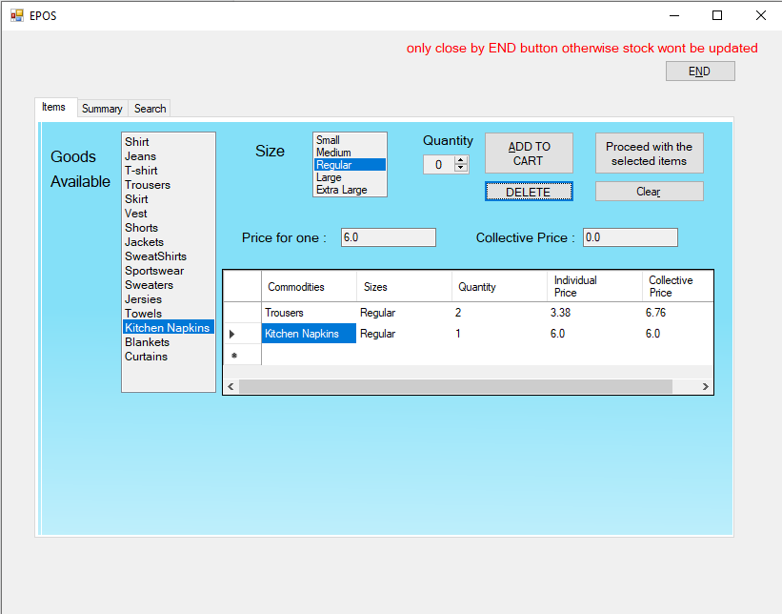

On proceeding further to complete the order the stock will be updated and you will be able to see the 2nd portion of the landing page which is complete order portion.In which you can see 3 buttons 2 enables complete order and cancel order, and one disabled new order and a textbox with the total amount of items.

On clicking cancelling the order the order will be cancelled and you will again see the portion 1 of the landing page like initially.

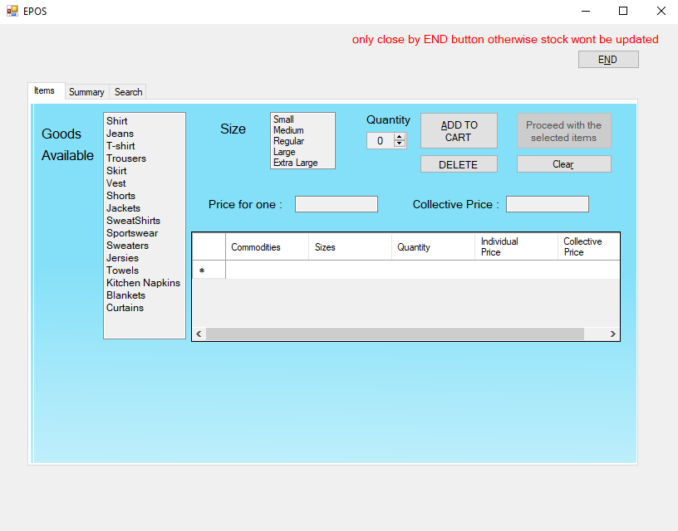

On clicking on complete order the transaction will be complete and updated in the “Orders.txt” file with order id date time and details items you have chosen. The stock will be updated accordingly. Cancel order will be disable and new order will be enables You will see a Message box with all the details.

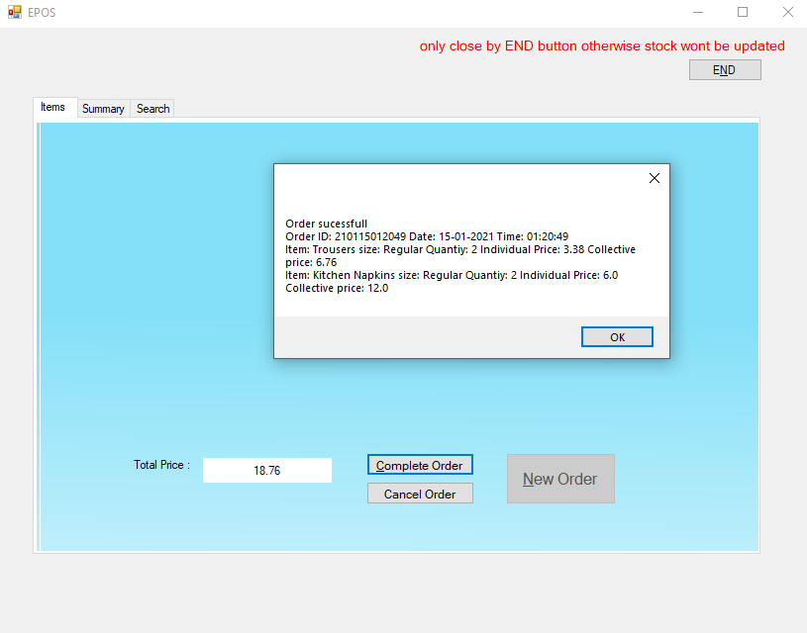

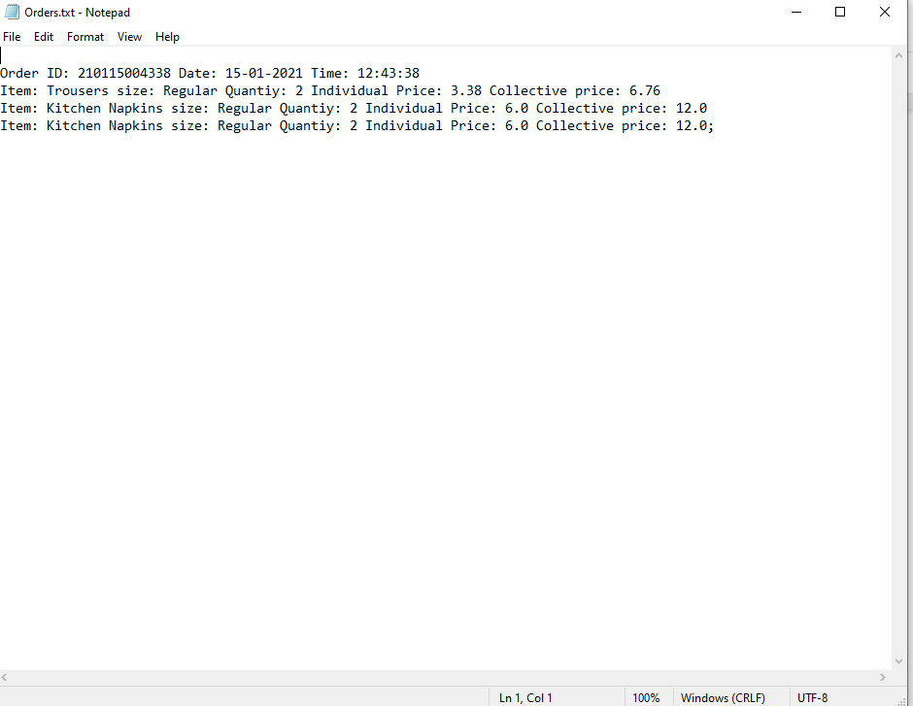

On Clicking new order you will be able to process a new order following the same above mentioned steps.

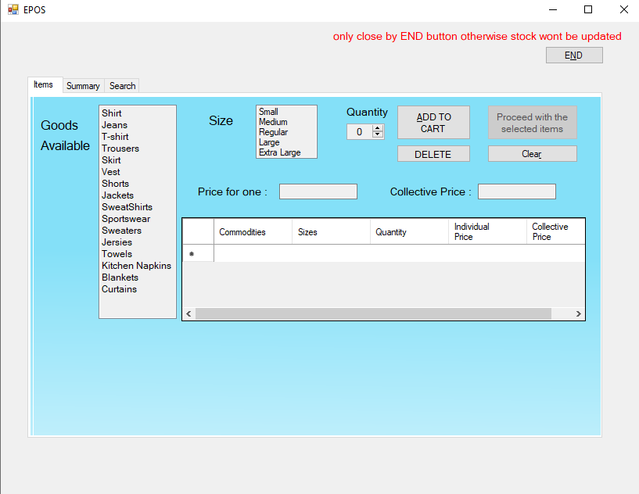

On switching to the summary tab you can see the summary of the daily sales page.

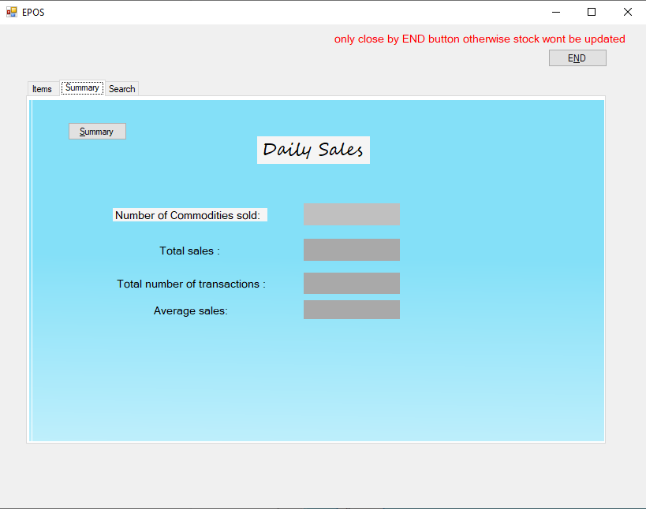

The page consists of a summary button which will generate the summary of sales on that particular day.

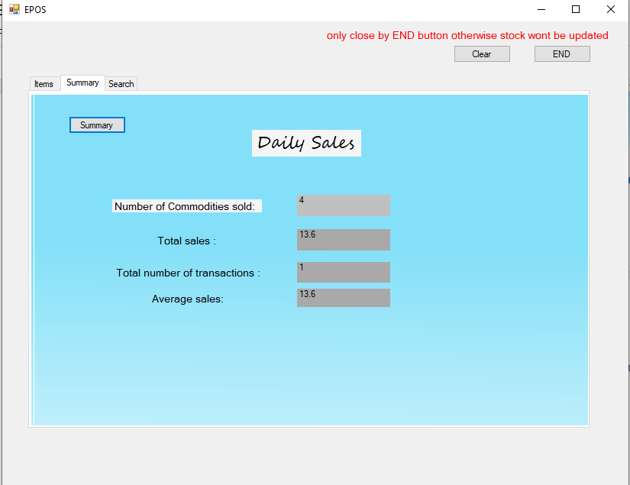

It will show the number of items sold, total sales, total number of transactions and average sales.

Now switching to the search tab you will be able to see a form where you can enter the order id and get the details of that transaction.

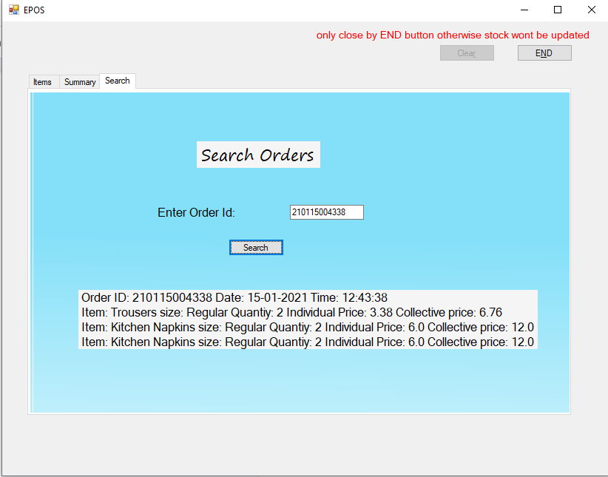

End button

On clicking end button will result in termination of application

If you haven’t completed any order then the clicking end button will directly terminate the application otherwise a dialogue box will appear on clicking yes the stock will be updated in “closing stock.txt” file.

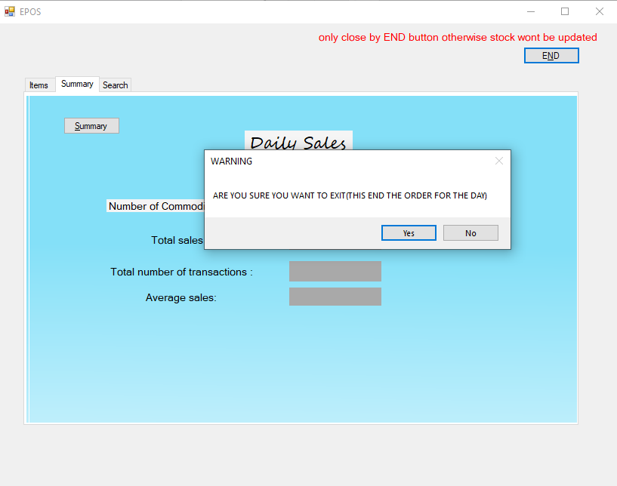

If you click NOit will take you to the landing page for a new order.

** if you close the application by red cross button on right corner the stock won’t be updated in the “Closing Stock.txt” file

**Warnings on wrong input**

Different types of warning pop-up will appear on entering or choosing the wrong input.

1. If you don't select anything and hit button

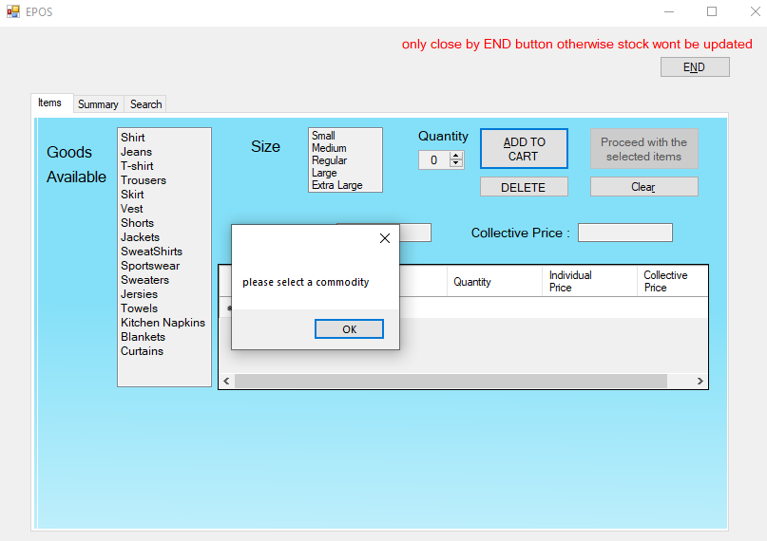

1. On not choosing the size

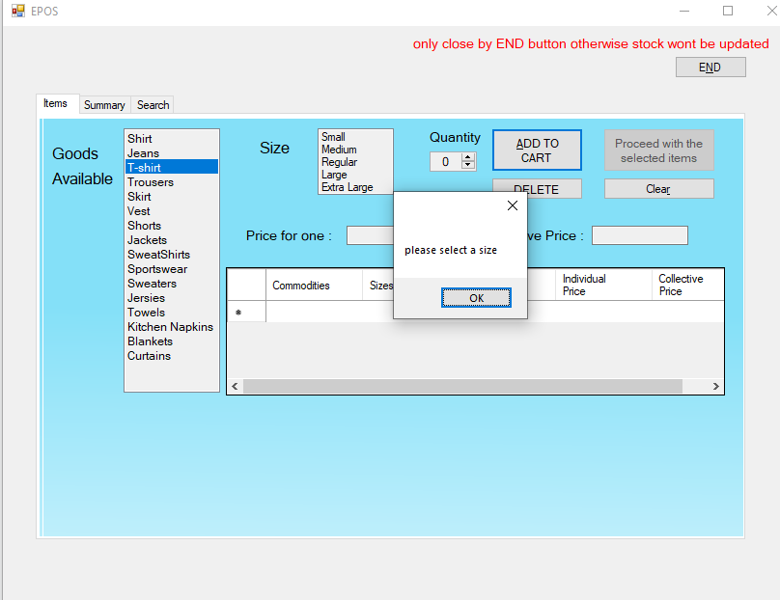

1. On entering the 0 as quantity.

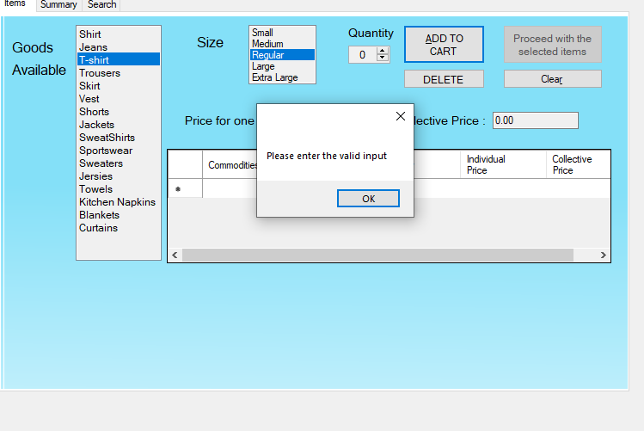

1. On entering more quantities than available.

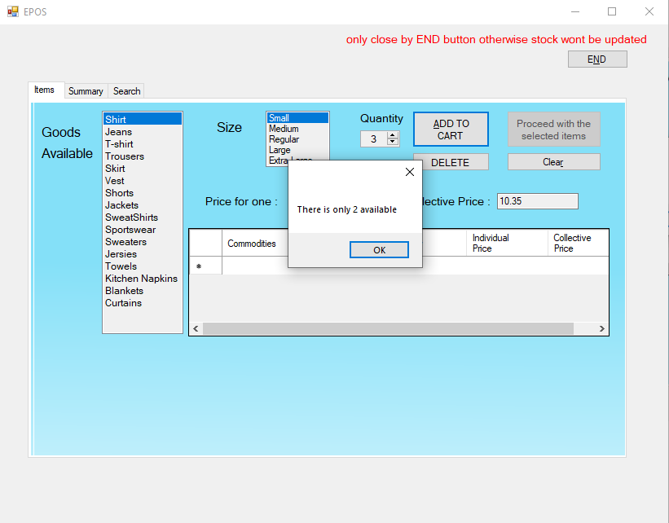

1. On selecting an empty row and deleting it.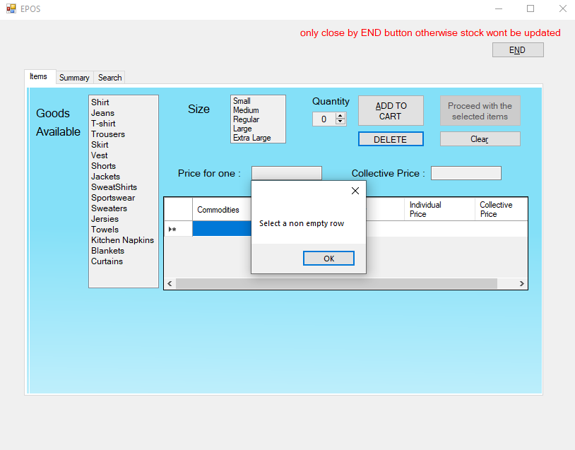
2. Wrong input in search will lead to finding nothing.

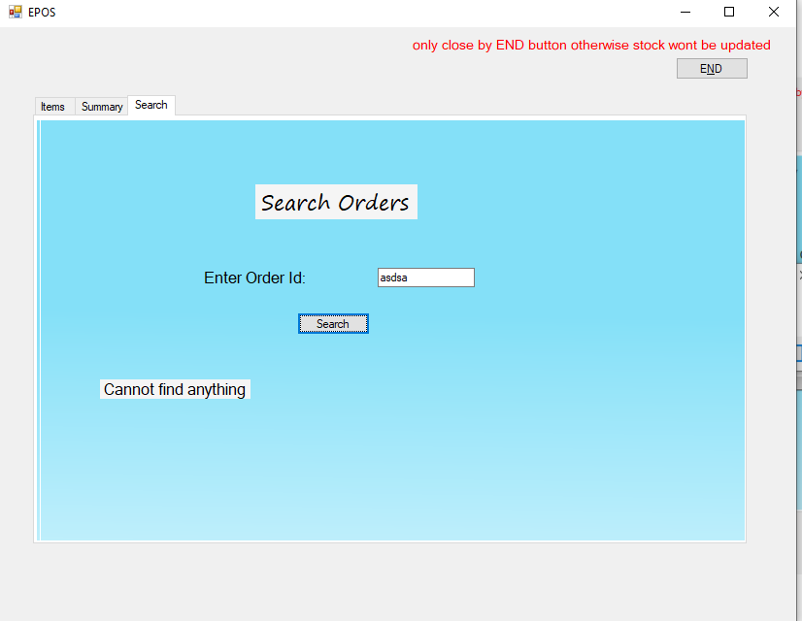

**Program flow**

Main flow

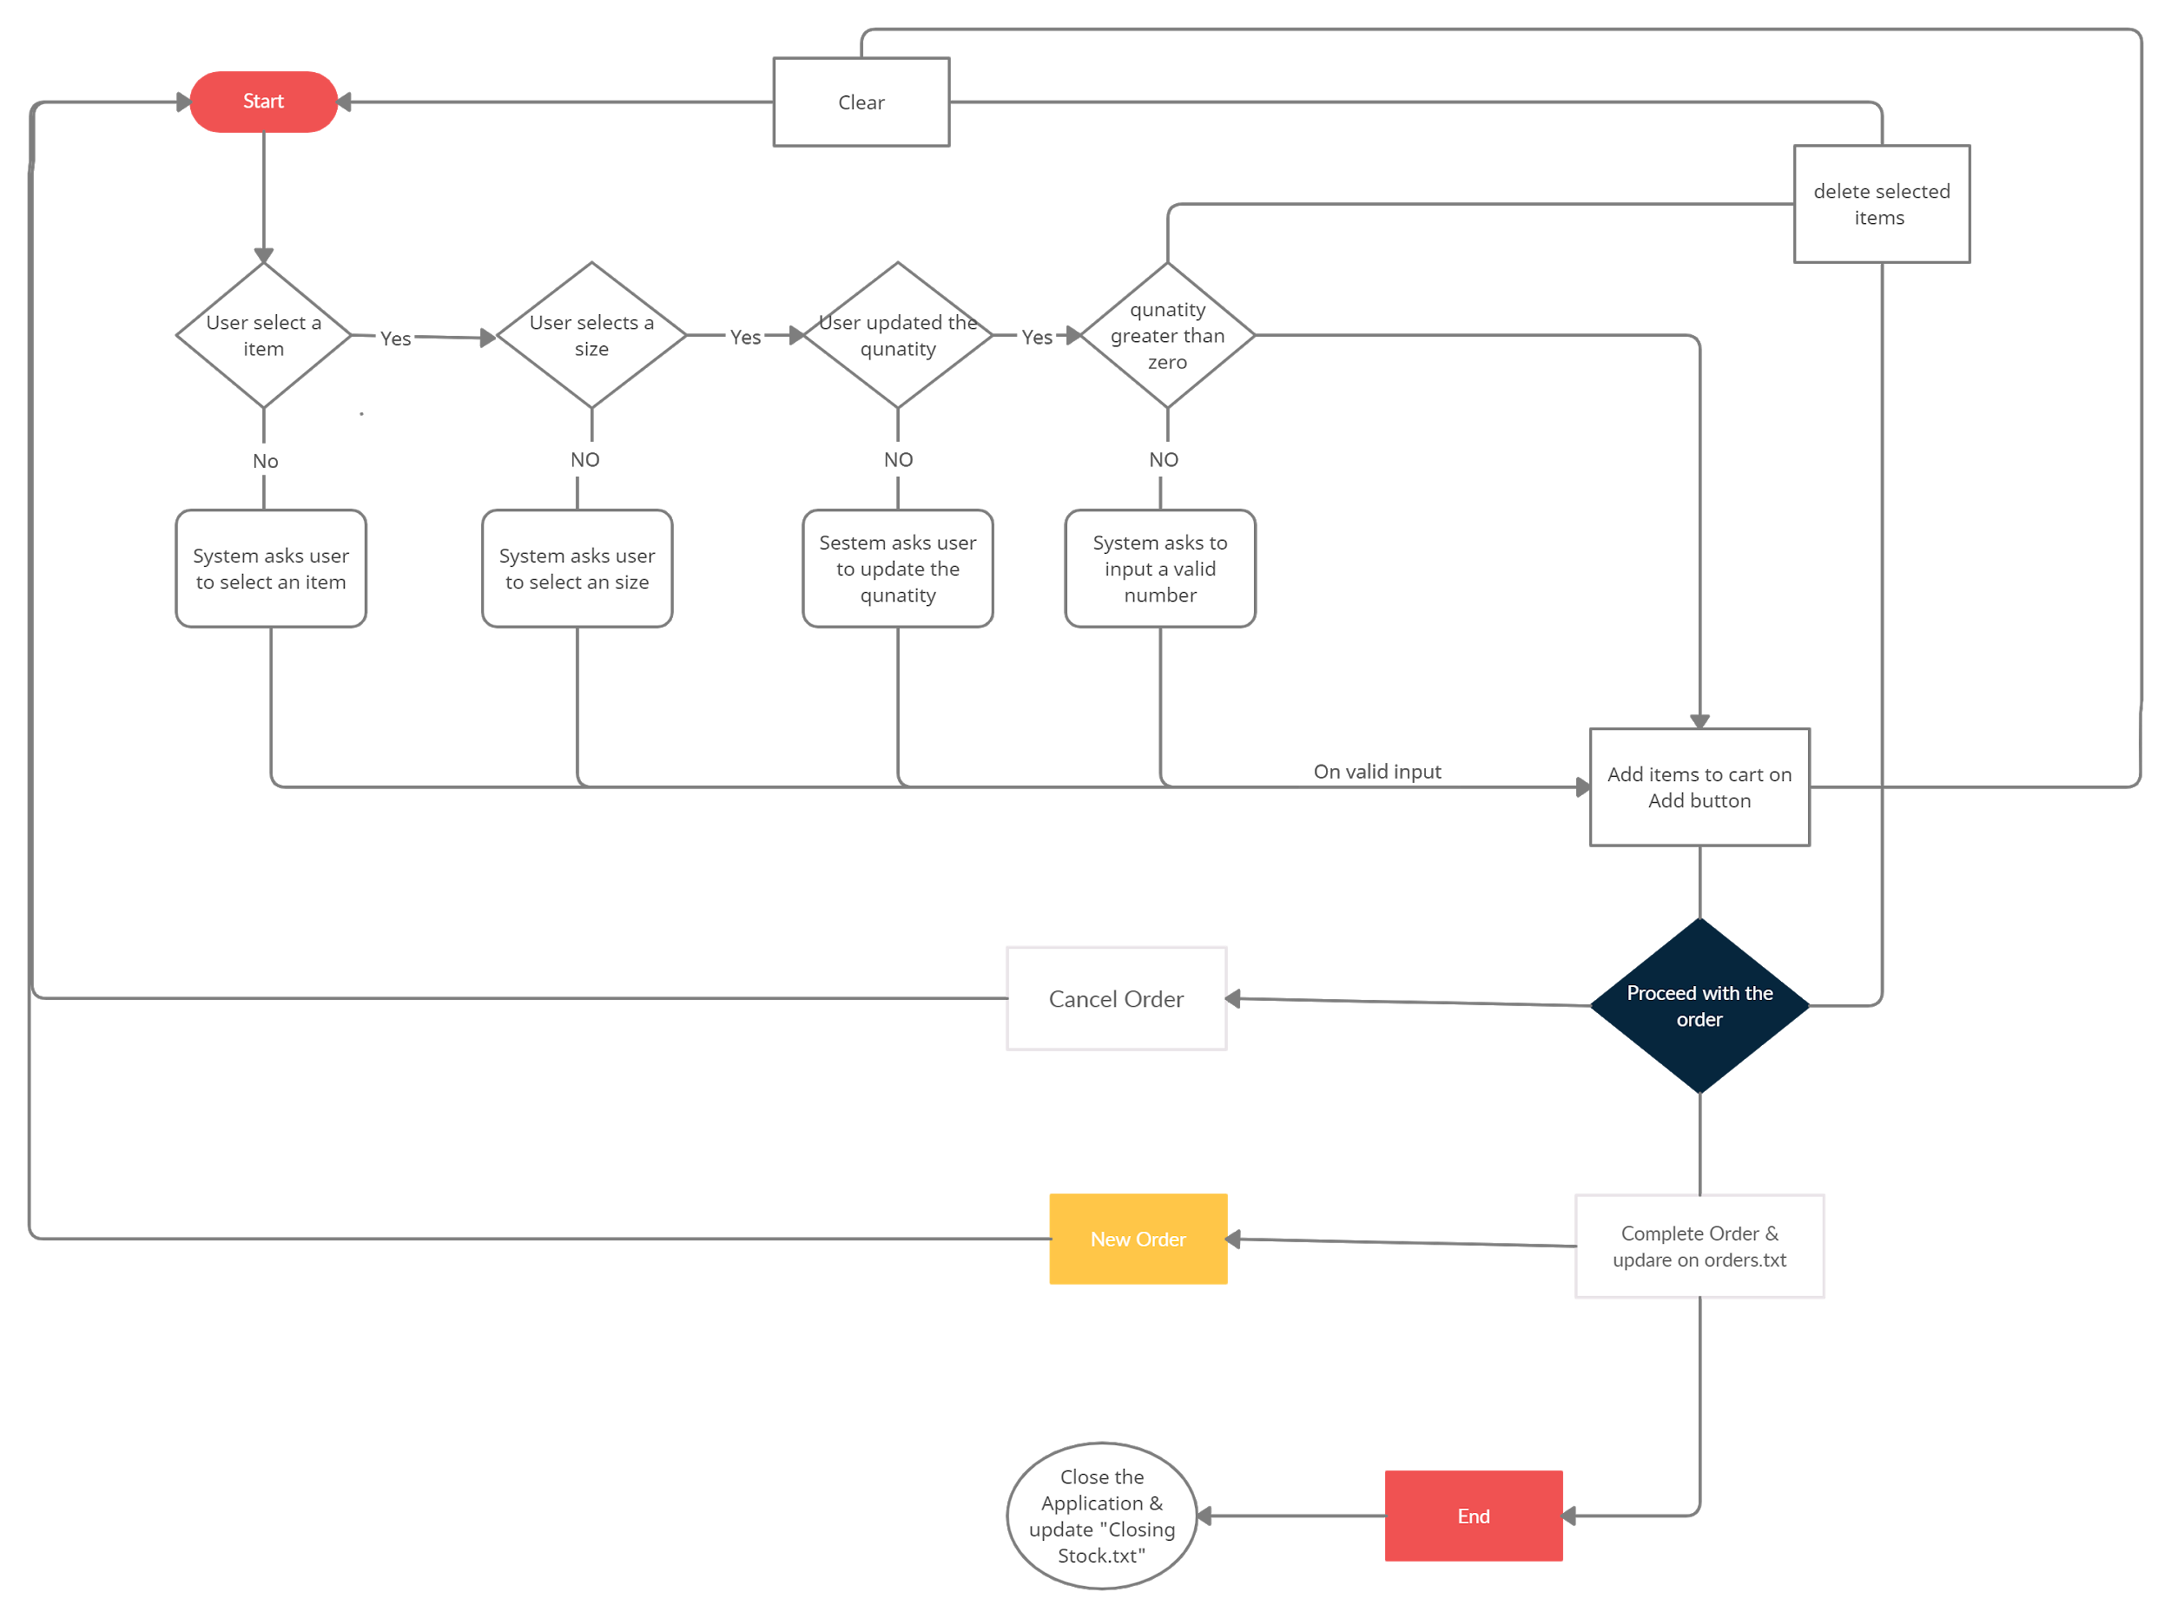

Search flow